# CGRA 352 – Assignment 3

300446258

Jackson Tume

*-Brief introduction of your functions in your programs.*

The main method of my function runs the FeatureMatch, which takes in the first image and second image. It then computes the features using the sift feature detector and brute force matcher. After computing the features the homography transform is computed, 4 random pairs are chosen, if the error is less than a set epsilon value its set as an inlier. This is repeated 100 times and the highest number of pairs is set as the best. Using this homography transform we know the feature pairs that are good and can remember, pairs drawn in red are bad and green are good.

*-How to run your program to perform the functions required by the assignment.*

To run my program, simply press play after building. The program will run and display the feature making (with the good and bad matches) and the aligned image.

*-The results of Core (left core1, right core2, bottom core3)*

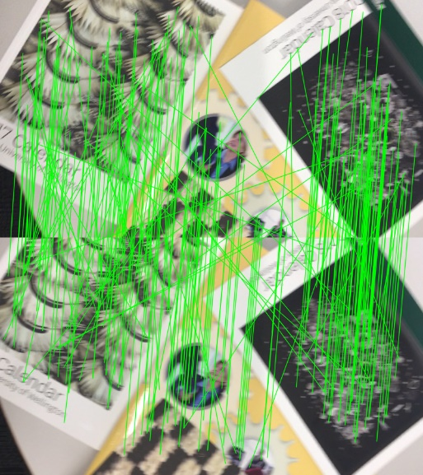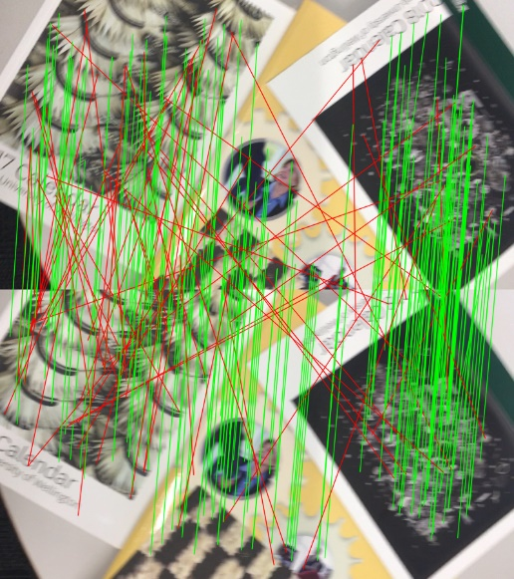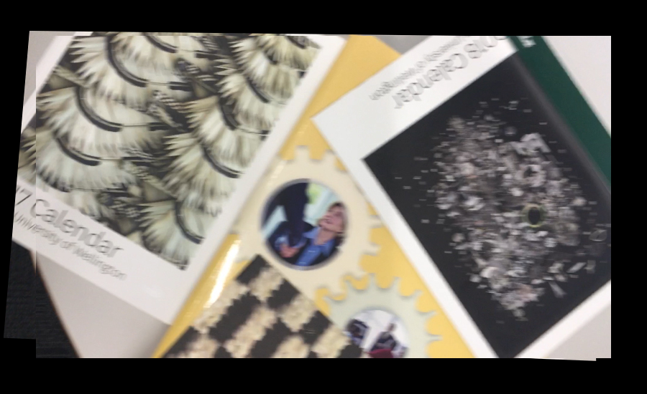

*Completion/Challenge Not Attempted